**Institute of Engineering & Management**

**Department of Computer Science & Engineering**

**Network Lab for 3rd year 6th semester 2019**

**Code: CS692**

**Date:**15/04/19

**WEEK-8**

**Assignment-1**

**Problem Statement:** Implementation of VLAN.

**Screen-Shot:**

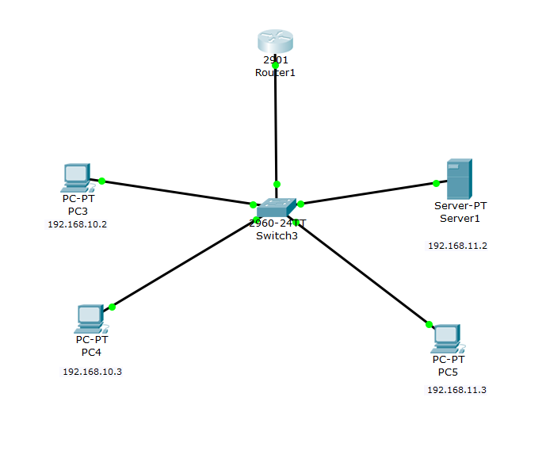

**CLI code:**

**Switch:**

Switch>en

Switch#vlan database

Switch(vlan)#vlan 2 name student

VLAN 2 added:

Name: student

Switch(vlan)#vlan 3 name faculty

VLAN 3 added:

Name: faculty

Switch(vlan)#exit

Switch#configure terminal

Switch(config)#interface range fastEthernet 0/1 - fastEthernet 0/2

Switch(config-if-range)#switchport mode access

Switch(config-if-range)#switchport access vlan 2

Switch(config-if-range)#exit

Switch(config)#interface range fastEthernet 0/3 - fastEthernet 0/6

Switch(config-if-range)#switchport mode access

Switch(config-if-range)#switchport access vlan 3

Switch(config-if-range)#exit

Switch(config)#exit

Switch#

Switch#showvlan

VLAN Name Status Ports

---- -------------------------------- --------- -------------------------------

1 default active Fa0/7, Fa0/8, Fa0/9, Fa0/10

Fa0/11, Fa0/12, Fa0/13, Fa0/14

Fa0/15, Fa0/16, Fa0/17, Fa0/18

Fa0/19, Fa0/20, Fa0/21, Fa0/22

Fa0/23, Fa0/24, Gig0/1, Gig0/2

2 student active Fa0/1, Fa0/2

3 faculty active Fa0/3, Fa0/4, Fa0/5, Fa0/6

1002 fddi-default active

1003 token-ring-default active

1004 fddinet-default active

1005 trnet-default active

Switch#config terminal

Switch(config)#interface fastEthernet 0/5

Switch(config-if)#switchport mode trunk

Switch(config-if)#exit

**Router:**

Router>en

Router#configterminal

Router(config)#interface gigabitEthernet 0/0

Router(config-if)#no shutdown

Router(config-if)#exit

Router(config)#interface gigabitEthernet 0/0.1

Router(config-subif)#encapsulation dot1q 2

Router(config-subif)#ip address 192.168.10.1 255.255.255.0

Router(config-subif)#no shutdown

Router(config-subif)#interface gigabitEthernet 0/0.2

Router(config-subif)#encapsulation dot1q 3

Router(config-subif)#ip address 192.168.11.1 255.255.255.0

Router(config-subif)#no shutdown

Router(config-subif)#end

Router#

Router#wr

Building configuration...

[OK]

Router#showip interface brief

Interface IP-Address OK? Method Status Protocol

GigabitEthernet0/0 unassigned YES unset up up

GigabitEthernet0/0.1 192.168.10.1 YES manual up up

GigabitEthernet0/0.2 192.168.11.1 YES manual up up

GigabitEthernet0/1 unassigned YES unset administratively down down

Vlan1 unassigned YES unset administratively down down

Router#